- Photos（The photo must be high-definition of the journal in hand）
- 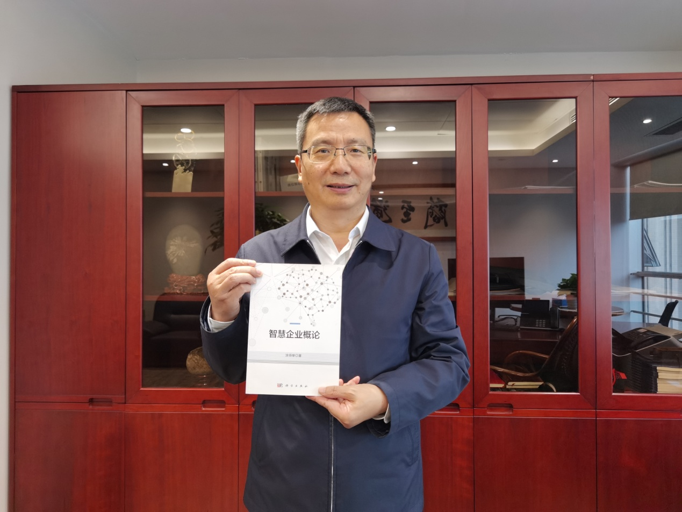

- Marital status: Marital
- Office Address: No. 7, Tianyun Road, Chengdu City, Sichuan Prov. China 610041.
- Website: https://baike.baidu.com/item/%E6%B6%82%E6%89%AC%E4%B8%BE/50335466?fr=ge_ala

EDUCATION
1982--1986, Bachelor, Department of Hydraulic Engineering, Fuzhou University.
2004--2007, Ph. D, Hydrology and water resources, Sichuan University.

DISTINCTIONS AND AWARDS
- Award the title of "Outstanding Business and Management Talent" by China State Grid Corporation, November 2004.
- Award “Outstanding Communist Party Member” and “First Class Red Flag Medal” by China State Grid Corporation, June 2005.
- Award “Excellent Entrepreneur in Sichuan Province” by the Sichuan Enterprise Federation and the Sichuan Entrepreneur Association, April 2006.
- Award “Outstanding Communist Party Member of Central Enterprises” by the State owned Assets Supervision and Administration Commission of the State Council, June 2006.
- Award “Excellent Business and Management Talent” by China State Grid Corporation for the second time, May 2007.
- Award “Top Ten Young Economic Figures in Sichuan Province” by eight departments including the Organization Department of the Sichuan Provincial Party Committee, the Propaganda Department of the Sichuan Provincial Party Committee, the Sichuan Provincial State owned Assets Supervision and Administration Commission, and the Sichuan Provincial Committee of the Communist Youth League, August 2007.
- Award “the State Grid Special Red Flag Medal” by China State Grid Corporation, January 2010;
- Award “Outstanding Entrepreneur of Sichuan Province” by the Sichuan Enterprise Federation and the Sichuan Entrepreneur Association, April 2010.
- Elected as the representative of the 8th Party Congress of Xinjiang Autonomous Region, August 2011.
- Rated as model worker of Sichuan Province, May 2015.
- Award the title of “National Excellent Entrepreneur”, December 2018.
- Won the title of “National model worker” in 2020.

EXPERIENCE
1986.07--1987.08, intern at the Independent Hydroelectric Detachment of the Armed Police Force (technical level 13 cadre)
1987.09--1988.08: Deputy Political Instructor of the Second Company of the Independent Hydroelectric Branch of the Armed Police Force
1988.09--1992.02: Assistant Engineer, Research Institute, Command Headquarters of the First Armed Police Hydroelectric Corps
1992.03--1993.04: Political Associate at the Research Institute of the Headquarters of the First Armed Police Hydroelectric Corps
1993.05--1994.12: Deputy Director and Engineer of the Research Institute of the Command Headquarters of the First Armed Police Hydroelectric Corps
1995.01--1997.06: Deputy Director of the Research Institute of the Headquarters of the First Armed Police Hydroelectric Corps (at the battalion level)
1997.07--1998.11: Director of the Research Institute of the Command Headquarters of the First Armed Police Hydroelectric Corps
1998.11--2001.10, served as the Director and Senior Engineer of the Research Institute of the Command Headquarters of the First Armed Police Hydroelectric Corps
2001.11--2003.01, worked as General Manager Assistant and Deputy Chief Engineer of Sichuan Zagunao Hydropower Development Co., Ltd
2003.02--2003.07, Deputy General Manager of Pubugou Hydropower Station Construction Branch of Guodian Dadu River Hydropower Development Co., Ltd
2003.07--2006.08, Executive Deputy General Manager of Pubugou Hydropower Station Construction Branch of Guodian Dadu River Hydropower Development Co., Ltd. (referring to the management at the department level)
2006.08--2008.03, General Manager and Deputy Secretary of the Party Committee of Pubugou Hydropower Station Construction Branch of CHN Energy Dadu River Hydropower Development Co., Ltd
2008.03--2011.05, served as the Deputy General Manager and Member of Guodian Dadu River Hydropower Development Co., Ltd., as well as the General Manager and Deputy Secretary of the Party Committee of Pubugou Hydropower Station Construction Branch
2011.05--2011.12, Secretary of the Party Group and Deputy General Manager of Guodian Xinjiang Electric Power Co., Ltd
2011.12--2014.03, Secretary of the Party Group and Deputy General Manager of Guodian Xinjiang Electric Power Co, Principal of the Party School
2014.03--2020.03, General Manager and Deputy Secretary of the Party Committee of Guodian Dadu River Hydropower Development Co., Ltd
2020.03- - present, Secretary of the Party Committee and Chairman of CHN Energy Dadu River Hydropower Development Co., Ltd

OTHER PROFESSIONAL ACTIVITIES
2014.06 - present, Director of China Dam Engineering Society

2016.11 - present, Executive Director of China Hydroelectric Engineering Society
2018.11 - present, Vice Chairman of the Smart Enterprise Promotion Committee of the China Enterprise Federation
2018.11 - present, Consultant to the Industrial Transformation Consultative Committee of Tsinghua University

HEAD OF APPLIED PROJECTS:
- Practical Study on Economic Operation of Dagangshan and Below Hydropower Stations in the Main Stream of Dadu River, contract with Sichuan University, 2015.
- Research on Intelligent Dispatching Technology for Cascade Hydropower Station Groups at and below Waterfall Gully, contract with Sichuan University and China Society for Hydropower Engineering, 2012.
- Research and Application of Intelligent Production Technology for Flood Control Dispatching Scheme of Dadu River Reservoir Group Based on Data Mining, contract with Hydrological Bureau of the Yangtze River Water Resources Commission, 2019.
- Research and application of snowmelt runoff prediction technology in the upper reaches of the Dadu River, contract with Hehai University, 2020.
- Research on Climate Statistical Dynamic Prediction Model in the Dadu River, contract with Chengdu University of Information Technology, 2020.
- Research on Multiscale Collaborative Dispatching Decision for Unit Gates of Cascade Hydropower Stations in the Middle Reaches of the Dadu River, contract with Hehai University, 2020.
- Construction of the Comprehensive Management System for Safety Information of the Reservoir Bank of the Pubugou Hydropower Station on the Dadu River, contract with China Power Construction Group East China Survey, Design and Research Institute Co., Ltd, 2015.
- Research on the Safety Risk Early Warning Management System Scheme for the Dam of the Dadu River Hydropower Station, contract with Sichuan University, 2016.

PUBLICATIONS:

Books:
- Tu Yangju. Risk Management of Electricity Marketing in Hydropower Enterprises, China Electric Power Publishing House, 2009, ISBN 9787508384573, 195 pp.
- Tu Yangju. Smart Enterprises: Framework and Practice,Economic Daily, 2018, ISBN 978751960406, 324 pp.
- Tu Yangju. Introduction to Smart Enterprises, Science Press, 2019, ISBN 9787030617644, 183 pp.
- Tu Yangju. Intelligent operation and management of hydropower enterprises, China Wate Power Press, 2021, ISBN 9787522602196, 162 pp.

Patents:
- China Patent ZL 2019 1 0070226.1, Tu Yangju, Zhou Yerong, Wang An, Li Lin, Mei Yan, A real-time online monitoring system for radial steel gates in hydroelectric engineering, 2019-01-24.
- China Patent ZL 2020 1 1212450.9, Tu Yangju, Luo Wei, Luo Liyun, Huang Ying, Multi-dimensional emotion recognition management method, system, processor, terminal, and medium, 2021-04-09.
- China Patent ZL 2021 1 0179194.6, Tu Yangju, Li Lin, Hou Yuanhang, Qian Bing, Ma Yue;, Mei Yan, Method and System for Online Monitoring of Unit Top Cover Bolts, 2021-05-04.

Articles and papers in Chinese peer-reviewed journals and edited volumes:
- Tu Yangju, Ma Guangwen, Luo Lunwu, Liu gang, Tao Chunhua. ‘Dam Construction Simulation System of Pubugou Hydropower Station based on Data driving,’ Water Power, 2006, vol.32, no.10,86-88.
- Tu Yangju, Ma Guangwen, Liu Zhili, Yan Bingzhong, Zuo Xing. ‘Mid-long term optimized operation system for hydropower stations based on three-layer B/S structure’, JOURNAL OF HYDROELECTRIC ENGINEERING, 2006, vol. 25, no. 2, 90-93.
- Tu Yangju, Ma Guangwen, Tao Chunhua, Guo Xiaming, Tang Ming. ‘Constructing Optimization of Moraine Dam Based on Accelerating Genetic Algorithm,’ Water Power, 2007, vol. 33. no. 1, 26-28.
- Tu Yangju, Wang Wentao, Chen Xianghao, Deng Jianhui, Chen Kewen, Wen Hao. ‘Monitoring and Analysis on Pubugou Gravel Soil Corewall Rockfill Dam during Construction Period,’ Water Power, 2010, vol. 36,no. 6, 71-74.

- Tu Yangju, Wang Wentao，Xue Xinhua,Seepage analysis of Pubugou high earch-rockfill dam. Hydroscience and Engineering，5)2013 (5): 77-82.

- Tu Yangju, How does a hydropower company construct an intelligent enterprise, Energy,2016 (8): 96-97.

- Tu Yangju, Data Drives Intelligent Enterprise. Enterprise Management, 2018 (2): 100-103.

- Tu Yangju, Convergence of Informatization, Industrialization and Management mordernization of an Intelligent Enterprise. Enterprise Management, 20

- 21

