Curriculum Vitae - JIANHUA YAN

Marital Status: Married, 1 Child
Office Address: Room 211, Institute of Thermal Engineering,
College of Energy Engineering, Zhejiang University
38, Zheda Road, Xihu District
Hangzhou city 310013
People’s Republic of China
https://person.zju.edu.cn/yanjh/746760.html

EDUCATION
Undergraduate
1978--1982, Bachelor's degree, Power Plant Thermal Energy, Zhejiang University (论文题目:宽筛分石煤流化床燃烧颗粒扬析特性, Thesis title “Elutriation Properties of Fine Particle from Bubbling Fluidized Bed Combustor of Burning Stone-like Coal”)
Postgraduate
1982--1985, Master's degree, Engineering Thermophysics, Zhejiang University (论文题目:脉动流化床流体动力特性研究, Thesis title “Flow Dynamic Characterization of Pulsating Fluidized Bed Combustor”)
1987--1990, Ph.D. degree, Engineering Thermophysics, Zhejiang University (论文题目: 煤在流化床中燃烧特性的研究, Thesis title “Study of Coal Combustion Characteristics in Fluidized Bed Combustor”)

DISTINCTIONS AND AWARDS
- Special allowance from the State Council, 1996
- Second Prize of National Technological Invention Award, Differential Gravity Bed Combustion Technology of Coal-water Mixture, 1997
- Changjiang Scholar Award, Ministry of Education of China, 2002
- Second Prize of China College Science and Technology Award, Research on Clean Combustion of Municipal Solid Waste, 2001
- First Prize of Zhejiang Province Science and Technology Award, Large-scale Processing Technology of Clean Combustion and Power Generation of Municipal Solid Waste, 2005
- Second Prize of National Science and Technology Progress Award, Integrated Technology of Clean Combustion and Power Generation of Municipal Solid Waste in Circulating Fluidized Bed, 2006
- China Patent Excellent Prize, Integrated Processing Equipment for Municipal Solid Waste in Differential Gravity Circulating Fluidized Bed Combustion, 2006
- First Prize of Zhejiang Province Science and Technology Award, Integrated Disposal Technology of Hazardous Waste Multi-stage Thermal Decomposition and Incineration, 2012
- First Prize of China Construction Science and Technology Award, Integration and Application of Sludge Thermal Drying and Combustion of Coal-fired Boiler, 2012
- Second Prize of National Science and Technology Progress Award, Indirect Thermal Drying and Clean Combustion of Sludge in Integrating Technology of Agitation Dryer and Complex Circulating Fluidized Bed, 2014
- Second Prize of National Teaching Achievement Award, “AGE” overall promotion, improvement of graduate training quality, 2014
- First Prize of Zhejiang Province Science and Technology Progress Award, Real-time Detection, Online Diagnosis and Optimized Control Technology of Field Parameters in Combustion Process, 2015
- Special-grade expert in Zhejiang Province, 2015
- National Science and Technology Progress Award (Innovation Team), Zhejiang University Energy Clean Utilization Innovation Team, 2016
- China Patent Excellent Prize, Hazardous Waste Circulating Fluidized Bed Three-stage Combustion Incinerator, 2016
- Second Prize of National Science and Technology Progress Award, Key Technology for Hazardous Waste Circulating Multi-stage Thermal Decomposition and Incineration and Pollutant Synergetic Control, 2017
- First Prize of National Teaching Achievement, Research-oriented university's research and 20 years of practical implementation of innovative entrepreneurial education system, 2018
- The National Innovation Leading Prize, 2020
- China Patent Golden Prize, Online Monitoring Method of Dioxin by Tunable Laser Spectroscopy Combined with Flight Time Mass Spectrometry, 2022
- First Prize of National Teaching Achievement, Exploration and Practice of Professional Master's Degree Education in "Polytechnic Institute" to Break Scatteredness, Break Barriers, and Break Homogeneity, 2022

EXPERIENCE
Permanent positions
1995-Present, Professor, College of Energy Engineering, Zhejiang University, Hangzhou, China

Visiting positions
1992-1993, Visiting Scholar, Department of Chemical Engineering, Technical University of Nova Scotia (Dalhousie University), Canada
1995-1996, Visiting Scholar, Department of Mechanical Engineering, University of Tokyo, Japan,

OTHER PROFESSIONAL ACTIVITIES
Founder and Head
- Waste Disposal & Sustainable Energy, Editor-in-chief (from 2018)
- State Education Commission Open Research Laboratory of Clean Combustion Technology (from 1993-1996)

Head, Co-chairman
- International Strategic Technology Alliance, Vice President (from 2015)
- Zhejiang Provincial Engineer Society, President (from 2023)
- Chinese Society of Power Engineering (CSPE), Vice President and CSPE International Cooperation Committee, Director (from 2015)
- Chinese Society of Engineering Thermophysics, Standing Director (from 2019)
- Development Committee in Zhejiang University, Vice Chairman (from 2022)
- State Key Laboratory of Clean Energy Utilization, Director (from 2020)
- the National Engineering Research Center for Clean and Efficient Utilization of Solid Waste Energy, Director (from 2016)

Member
-Member of the Academic Degree Committee of the State Council on Power Engineering and Engineering Thermophysics (2009-2020)
-Vice Director Member of the National Graduate Education Steering Committee for Professional Engineering Degree (2020-present)

Member of Editorial Board for the Journals
- Waste Disposal & Sustainable Energy, Editor-in-chief (from 2018)
- Journal of Zhejiang University-SCIENCE A, Associate editor (from 2016)
- Waste Management (from 2018)
- Journal of Engineering Thermophysics (from 2012)
- China Energy (from 2006)
- Journal of Fuel Chemistry (from 2005)

Plenary Speaker
1. Jianhua Yan, "Sustainable Treatment and Utilization of MSWI Fly Ash", 2023, International Conference on Solid Wastes, Hong Kong, China
2. Jianhua Yan, “Waste to Energy/Incineration (MSW, hazardous waste, sludge)”, 2020, 8th International Symposium on Energy from Biomass and Waste, Venice Virtual Event.
3. Jianhua Yan, “WTE Status and Technology Development”, 2019, International Conference on Solid Waste, Hangzhou, China.
4. Jianhua Yan, “Waste to Energy”, 2017, Word Economic Forum Annual Meeting, Dalian, China.
5. Jianhua Yan, “Clean Coal Research at China”, 2017, World Economic Forum Annual Meeting, Davos, Switzerland.
6. Jianhua Yan, Fei Wang, Qunxing Huang, Yong Chi, “Advanced Thermal Technology for Sewage Sludge Treatment using Stirring Dryer and Circulating Fluidized Bed”, 2015, International Conference on Solid Waste, Hong Kong, China.
7. Jianhua Yan, “Recent Achievements for Thermal Treatment of Combustible Solid Waste”, 2014, The 8th International Conference on Combustion, Incineration/Pyrolysis, Emission and Climate Change, Hangzhou, China.
8. Jianhua Yan, Hongmei Liu, Xiaodong Li, Xiaojun Ma, Shengyong Lu, Tong Chen, “Health Risk Assessment of PCDD/F Emissions from Municipal Solid Waste Incinerators (MSWIs) in China”, 2011, International Conference on Solid Waste, Hong Kong, China.
9. Kefa Cen, Jianhua Yan (presenter), Yong Chi, Xiang Gao, Xiaodong Li, Zhongyang Luo, Mingjiang Ni, Alfons Buekens, “Achievements and Challenges for Clean Energy Utilization in China”, 2011, The 12th International Congress on Combustion By-Products and their Health Effects: Combustion Engineering and Global Health in the 21st Century - Issues and Challenges, Hangzhou, China.
10. Jianhua Yan, “Fluidized Bed Based Incineration Technology for Treatment of Municipal Solid Waste”, 2010, International Conference on Environmental Protection Technology and Standard, Hangzhou, China.
11. Jianhua Yan, “Application of Some Measurement Techniques for Multiphase Flows in Energy & Environment Engineering”, 2004, The 4th International Symposium on Measurement Techniques for Multiphase Flows, Hangzhou, China.

GRANTS
The International
-National Key Research and Development Program of China, International Programs & Strategic Innovative Programs between China and United States (Grant No.2017YFE0107600), “Research of online detection technology for trace organic pollutants emitted by incineration sources and application of combustion optimization” Chief Scientist (from 2018-2020)
-China-South Korea Cooperation project, “South Korea 50t/d sludge incineration project”, Chief Scientist (from 1994)
-China-France cooperation project, “Study on the treatment of wastewater and fly ash by plasma technology”, Chief Scientist (from 2005-2007)
-China-Thailand Cooperation project, “Agreement of Cooperation on Consultancy Services and Conceptual Design of CFB Incineration Technology”, Chief Scientist (from 2007-2008)
-China-Italy Cooperation project, “China's Strategy for the reduction of unintentional persistent organic pollutant byproducts: Best available technologies, best environmental practices, and incremental cost estimates for pilot industries”, Chief Scientist (from 2005)

The China
-National Natural Science Foundation of China (Key Program, Grant No.52236008), “Study on the Cascade conversion mechanism of organic solid waste with high contents of heavy metals/chlorine and sulfur from multi-sources”, Chief Scientist (from 2023-2027)
- Innovative Research Groups of the National Natural Science Foundation of China (Grant No.51621005),"Thermal Conversion Mechanism and Clean Utilization of Solid Fuels", Chief Scientist (from 2017-2022)
- The National 973 Project (Grant No. 2011CB201500) "Mechanism Research of Efficient and Clean Utilization of Combustible Solid Waste", Chief Scientist (from 2010-2015)
-National High-tech R&D Program of China (863 Program) (Grant No. 2007AA061302), “Key technologies and demonstration of hazardous waste incineration system”, project leader (from 2007-2010)
-National Science and Technology Major Project (Grant No. 2009ZX07317-003), “Research and Engineering Demonstration on Key Technologies of Sludge Reduction, Harmlessness and Comprehensive Utilization in Municipal Sewage Treatment Plants”, project leader (from 2009-2011)

HEAD OF APPLIED PROJECTS
Prof. Yan is leading his team to actively engage in the development of industry-academia-research in the field of solid waste disposal, involving applied project contract funds above 419 million RMB.

Projects related to MSW treatment.
Including high-tech industry demonstration project-800 tons/day large-scale clean incineration treatment of municipal solid waste, development of fluidized bed incineration boiler for municipal solid waste, etc.
The developed technology has been applied to 50 Waste-to-Energy projects in China.

Projects related to Sludge treatment.
Including Jiaxing Xinjiaisi Thermal Power Co., Ltd. sludge incineration demonstration project, collaborative Resource Utilization and Multi-Supply of Biogas from Sludge and Sewage, Industrial Park Noise Control, and Technological Development for Green and Low-Carbon Development., etc.
The developed dry incineration equipment has been applied to 116 sets.

Projects related to Hazardous waste treatment.
Including Medical and Industrial Waste Incineration Disposal Project in Quzhou, pyrolytic incineration technology of multi-stage medical waste in rotary fluidized bed, etc.
The developed technology has been applied to 58 hazardous waste disposal projects in 21 provinces of China.

Projects related to dioxin treatment.
Including Tunable laser spectroscopy combined with time-of-flight mass spectrometry for on-line monitoring of dioxins, study on the strategy of centralized cleaning and disposal of solid waste in Hangzhou with near zero dioxin emission, etc.
The core patent was transferred at a unit price of 8,571,500 RMB and was adopted by many leading enterprises in China's waste incineration industry.

Supervision of Master and Ph.D. Theses
Professor Yan has trained over 100 graduate students and has won two First prizes of The National Teaching Achievement Award and one Second Prize of The National Teaching Achievement Award.

Selected Master Theses
- Shen Y.L., Fluid-dynamic Characteristics and Numerical Simulations of an Impingement Gas-solid Separator for Circulating Fluidized Bed, Zhejiang University, 1996.
- Ma Z.Y., Experimental Study and Nonlinear Analysis of Transient Heat Transfer Characteristics in Circulating Fluidized Bed, Zhejiang University, 1995.
- Zhong L., Research of Gliding Arc Discharge Plasma Assisted Reforming of Methane into Hydrogen, Zhejiang University, 2010.
- Fang J.Y., Study on Sludge Drying Mechanism, Zhejiang University, 2011.
- Zhang L., Investigation on Vitrification of Simulated Medical Wastes by Thermal Plasma, Zhejiang University, 2012.
- Cheng Z.R., Study on Controlling of Dioxin Emissions from Iron Ore Sintering Process, Zhejiang University, 2014.
- Meng W.J., Research on Dioxin Emission and Behavior from a Cement Kiln Co-processing MSW, Zhejiang University, 2015.
- Yu L.B., Denitrification Process NH3 Concentration Measurements Based on Tunable Diode Laser Absorption Spectroscopy, Zhejiang University, 2016.
- Duan L.P., Ab Initio Characterization and Experimental Study on Graphene Based Formaldehyde Sensors, Zhejiang University, 2018.
- Qian Y.D., Study on the Mechanism of Internal Heating Melting by Resistance Electrothermal of Mswi Fly Ash, Zhejiang University, 2022.

Selected Ph.D. Theses
- Ma ZY. Research on CFB Boiler Heat Transfer, Wear and PC Flame Temperature Field on-line Measurement Technology, 1998.
- Xue F. Research on Flame Temperature Field Measurement Based on Radiative Images. Zhejiang University, 1999.
- Li S.Q. Pyrolysis of Solid Wastes for Clean Fuels and Chemicals: Lab- and Pilot-Scale Studies. Zhejiang University, 2002.
- Wang F. Temperature Field Measurement And Combustion Diagnose Based On Computer Image Processing Technique, 2000
- Zhang D.P. Study on Acid Gaseous Emission and its Artificial Neural Networks Predication in an MSW-Fired Fluidized Bed. Zhejiang University, 2003.
- Huang Q.X. Study on the Radiative Properties of Particulate Media in Coal-firing Boiler and Combustion Optimizing Technique. Zhejiang University, 2005
- Tu X. Characterization of DC Plasma Jets Aimed at the Treatment of Hazardous Waste. Zhejiang University, 2007.
- Bo Z. Fundamental Research of the Treatment of Volatile Organic Compounds with Gliding Arc Discharge Plasma. Zhejiang University, 2008.
- Lin X.Q. Research of PCDD/Fs Inhibition from Waste Incinerator by S-N-containing Compounds. Zhejiang University, 2015.
- Wu A.J. Study on the Characterization of Solid Products from the Decomposition of Methane and the Technology of Decomposition of Waste Bio-oil by Low Temperature Plasma. Zhejiang University, 2017.

PUBLICATIONS
Books
- Yan J.H., Wang F., Chi Y., Jiang X.G., Li X.D., Huang Q.X. Harmless Energy-saving Thermal Disposal Technology for Sludge. Beijing, China Electric Power Press, (Chinese), ISBN: 9787512370234, 2016, 252.
- Yan J.H., Du. C.M. Hydrogen generation from ethanol using plasma reforming technology, Zhejiang University Press & Springer, (English), ISBN: 9787308187664, 2017, 99.
- Du. C.M., Yan J.H. Plasma remediation technology for environmental protection, Zhejiang University Press & Springer, (English), ISBN: 9787308180139, 2017, 71.
- Cen K.F., Ni M.J., Yan J.H., Li X.D., Chi Y. Technologies of Combustible Solid Waste to Energy, Beijing, Chemical Industry Press, (Chinese), ISBN: 9787122261977, 2016, 535.
- Chi Y., Li X.D., Yan J.H., Ni M.J., Cen K.F. Coal Slurry and Sludge Treatment Incineration Technology and Engineering Examples. Beijing, Chemical Industry Press, (Chinese), ISBN: 9787502575984, 2013, 153.
- Cen K.F., Ni M.J., Yan J.H., Luo Z.Y., Li X.D., Fang M.X., Li X.T., Chi Y., Gao X., Jiang X.G., Cheng L.M. Gas-Solid Separation Theory and Technology. Hangzhou, Zhejiang University Press, (Chinese), ISBN: 9787308020954, 1999, 698.
- Cen K.F., Ni M.J., Luo Z.Y., Yan J.H., Chi Y., Fang M.X., Li X.T., Cheng L.M. Circulating Fluidized Bed Boiler: Theory, Design, and Operation. Beijing, China Electric Power Press, (Chinese), ISBN: 9787801254580, 1998, 754.
- Cen K.F., Cao Y.Q., Yuan Z.F., Cao. X.Y., Yan J.H. Boiler Combustion Test Research Methods and Measurement Technology. Beijing, China Water & Power Press, (Chinese), ISBN: 7-120-00007-1, 1987, 317.

Copyright certificates and patents
Granted more than 90 Chinese invention patents, the following are the selected 30 patents:
- CN201811281147.7. 一种利用磁场加强刀片滑动弧的温室气体转化装置及方法. 李晓东, 张浩, 李澧, 严建华, 岑可法. 中国. 28. 11. 2018.
- CN201811497666.7. 一种模拟利用旋转滑动弧在线裂解工业中产生焦油的系统. 张浩, 李晓东, 孔相植, 严建华, 岑可法. 中国. 04. 11. 2018.
- CN201910370640.4. 一种吸光隔热一体化光热蒸发材料及其制备方法和应用. 薄拯, 杨化超, 吴声豪, 严建华, 岑可法. 中国. 03. 07. 2019.
- CN201910993860.2. 余热锅炉换热管. 马增益, 李文瀚, 张艺颗, 严建华, 高若峰, 陈哲, 蔡亚明, 钟蒲城. 中国. 09. 10. 2019.
- CN201711228226.7. 基于高光谱图像的火焰温度场颗粒气体浓度场测量方法. 王飞, 谢正超, 严建华, 池涌, 黄群星, 倪明江, 岑可法. 中国. 22. 11. 2017.
- CN201910001099.X. 一种与催化剂结合的滑动弧等离子体有机物处理装置. 吴昂键, 严建华, 李晓东, 许睿飏, 张浩, 岑可法. 中国. 01. 10. 2019.
- CN201810949302.1. 一种错列式炉排炉生活垃圾气化方法. 汪守康, 黄群星, 白力, 严梦帆, 黄洁, 彭小龙, 杜海亮, 池涌, 王飞, 严建华. 中国. 09. 10. 2018.
- CN201810478657.7. 一种利用低温等离子技术协同处理有机废液和制备石墨烯的装置及方法. 吴昂键, 杨健, 李晓东, 张浩, 严建华, 岑可法. 中国. 04. 10. 2018.
- CN201810967722.2. 具有吸附和催化功能的改性粉煤灰及其制备方法和应用. 陈彤, 瞿铭良, 林樱, 肖晓辉, 陈大栋, 高孝国, 黄瑞亭, 严建华. 中国. 10. 09. 2018.
- CN201710108399.9. 循环流化床生活垃圾焚烧锅炉炉膛出口烟气含氧量的预测系统及方法. 尤海辉, 马增益, 唐义军, 王月兰, 严建华, 倪明江, 池涌, 岑可法, 黄群星. 中国. 10. 10. 2017.
- CN201811496183.5. 一种具有高运行稳定性的滑动弧等离子体反应器. 张浩, 李晓东, 孔相植, 严建华, 岑可法. 中国. 04. 11. 2018.
- CN201710499400.5. 一种含油污泥与生物质复合制备多级孔活性炭的方法. 黄群星, 林炳丞, 王君, 马增益, 金余其, 王飞, 蒋旭光, 池涌, 严建华. 中国. 04. 10. 2017.
- CN201910077049.X. 扰动增强型介质阻挡放电活化二氧化碳的反应装置及方法. 张浩, 李晓东, 李澧, 严建华, 岑可法. 中国. 07. 10. 2019.
- CN201910077048.5. 脉动射流等离子体协同转化温室气体和生物炭的系统及方法. 张浩, 李晓东, 李澧, 严建华, 岑可法. 中国. 07. 10. 2019.
- CN201810147535.X. 一种焚烧炉内生活垃圾组分实时检测装置和方法. 黄群星, 王亚飞, 汪守康, 池涌, 严建华, 王飞, 陆胜勇, 李晓东. 中国. 10. 14. 2018.
- CN201710499399.6. 一种含油污泥制备高含量芳香烃产物的方法. 黄群星, 林炳丞, 王君, 马增益, 金余其, 王飞, 蒋旭光, 池涌, 严建华. 中国. 04. 10. 2017.
- CN201710348326.7. 一种餐厨垃圾水热液化制取燃料油的方法. 池涌, 舒迪, 王飞, 蒋旭光, 严建华, 黄群星, 李晓东, 陆胜勇. 中国. 03. 10. 2017.
- CN201710108979.8. 循环流化床生活垃圾焚烧锅炉 NOx 排放的预测系统及方法. 尤海辉, 马增益, 唐义军, 王月兰, 严建华, 倪明江, 池涌, 岑可法, 黄群星. 中国. 10. 10. 2017.
- CN201710110224.1. 循环流化床生活垃圾焚烧锅炉 CO 排放预测系统及方法. 尤海辉, 马增益, 唐义军, 王月兰, 严建华, 倪明江, 池涌, 岑可法, 黄群星. 中国. 10. 11. 2017.
- CN201710056568.9. 三段式工艺的生活垃圾与高碱煤协同热解气化装置及方法. 黄群星, 胡斌航, 池涌, 严建华, 李晓东, 蒋旭光, 马增益, 王飞, 陆胜勇, 金余其. 中国. 05. 10. 2017.
- CN201610611569.0. 循环流化床生活垃圾焚烧锅炉床温预测方法及系统. 尤海辉, 马增益, 唐义军, 王月兰, 倪明江, 严建华. 中国. 06.10. 2016.
- CN201610398791.7. 循环流化床生活垃圾焚烧锅炉汽包水位的预测系统及方法. 尤海辉, 马增益, 唐义军, 王月兰, 倪明江, 严建华. 中国. 03. 10. 2016.
- CN201610205867.X. 循环流化床生活垃圾焚烧炉入炉热值实时预测系统及方法. 尤海辉, 马增益, 唐义军, 王月兰, 倪明江, 严建华. 中国. 20. 10. 2016.
- CN201610200890.X. 一种储运油泥制备的高比表面微孔活性炭及其制备方法. 王君, 刘天璐, 黄群星, 马增益, 池涌, 严建华, 王飞, 陆胜勇, 李晓东, 薄拯, 蒋旭光, 金余其. 中国. 2016.
- CN201510755817.4. 一种复合炉催化气化的装置及方法. 陆鹏, 黄群星, 唐一菁, 胡斌航, 池涌, 严建华, 李晓东, 蒋旭光, 马增益, 金余其, 王飞, 陆胜勇, 薄拯. 中国. 07. 10. 2015.
- CN201510409452.X. 一种低飞灰排放的炉内烟气再循环污泥颗粒焚烧炉. 黄群星, 于奔, 周国顺, 薄拯, 王飞, 蒋旭光, 池涌, 严建华. 中国. 4. 10. 2015.
- CN201510391535.0. 机械化学结合水洗的飞灰高效低成本无害处置方法和系统. 陆胜勇, 严建华, 李晓东, 陈志良, 蒋旭光, 池涌, 倪明江, 岑可法. 30. 11. 2015.
- CN201510338954.8. 一种高浓度有机废磷液的处理系统及处理方法. 马增益, 赵劲潮, 严建华, 池涌, 李晓东, 蒋旭光, 黄群星, 倪明江, 岑可法, 尤海辉, 王月兰, 陈超, 张艺颗. 08. 12. 2015.
- CN201510310329.2. 一种滞后对象时间补偿控制方法. 王月兰, 唐义军, 马增益, 尤海辉, 严建华, 倪明江, 沈跃良, 颜祝明, 罗建明, 岑可法. 29. 11. 2015.
- CN201510225207.3. 一种用于压制型煤的液压成型装置及其控制方法. 陆胜勇, 严建华, 李晓东, 池涌, 李文娟, 黄群星, 蒋旭光, 王飞, 倪明江, 岑可法. 23. 06. 2015.

National/industry standards, technical guidelines and guidelines

- Yan J.H., Li X.D., Lu S.Y., et al., Technical requirement of laser ionization - time-of-flight mass spectrometry online monitoring system for dioxins in the municipal solid waste incineration flue gas (T/CAEPI 28-2020), China Association of Environmental Protection Industry, Beijing, 2020.
- Wang Y.L., Yan J.H., Wang W.Z., et al., Municipal solid waste fluidized bed incineration boiler (GB/T-34552-2017), General Administration of Quality Supervision, Inspection and Quarantine, Beijing, 2017.
- Yan J.H., Li X.D., Wang Y.L., et al., Technical guideline for assessment on municipal solid waste fluidized bed incineration plants (RISN-TG018-2015), China Architecture & Building Press, Beijing, 2015.
- Yan J.H., Li X.D., Wang Y.L., et al., Technical guideline on municipal solid waste fluidized bed incineration (RISN-TG016-2014), China Architecture & Building Press, Beijing, 2014.
- Wang Q., Huang Q.F., Li L., Wang X.R., Long J.S., Nie Y.F., Jin Y.Y., Guo X.X., Tian H.H., Liu A.M., Yan J.H., Li X.D., et al., Standard for pollution control on the municipal solid waste incineration (GB-18485-2014), Ministry of Environmental Protection of the People's Republic of China, Beijing, 2014.
- Yang R., Wang H.C., Chen T.B., Zhang C., Kong X.J., Tang J.G., Huang O., Yan J.H., et al., Technical guidelines for sludge treatment and disposal in municipal wastewater treatment plants, China Architecture & Building Press, Beijing, 2012.

Articles in English in peer-reviewed journals and edited volumes

Prof. Yan has published more than 500 SCI papers. The articles have been cited nearly 20,000 times, with an H-index of 70. The following are selected 20 papers:

- Deng W.Y., Yan J.H.*, Li X.D., Wang F., Zhu X.W., Lu S.Y., Cen K.F. “Emission characteristics of volatile compounds during sludges drying process”, Journal of Hazardous Materials，2009, No. 161(1), 186-192, Doi: 10.1016/j.jhazmat.2008.05.022.
- Deng W.Y., Yan J.H.*, Li X.D., Wang F., Lu S.Y., Chi Y., Cen K.F. “Measurement and simulation of the contact drying of sewage sludge in a Nara-type paddle dryer”, Chemical Engineering Science, 2009, No. 64(24), 5117-5124, Doi: 10.1016/j.ces.2009.08.015.
- Yan J.H., Zhu H.M., Jiang X.G.*, Chi Y., Cen K.F. “Analysis of volatile species kinetics during typical medical waste materials pyrolysis using a distributed activation energy model”, Journal of Hazardous Materials, 2009, No. 162(2-3), 646-651, Doi: 10.1016/j.jhazmat.2008.05.077.
- Liu D., Huang Q.X., Wang F., Chi Y., Cen K.F., Yan J.H*. “Simultaneous measurement of three-dimensional soot temperature and volume fraction fields in axisymmetric or asymmetric small unconfined flames with CCD cameras”, Journal of Heat Transfer-Transactions of the ASME, 2010, No. 132(6), 1-7, Doi: 10.1115/1.4000752.
- Yan J.H., Chen T.*, Li X.D., Zhang J., Lu S.Y., Ni M.J., Cen K.F. “Evaluation of PCDD/Fs emission from fluidized bed incinerators co-firing MSW with coal in China”, Journal of Hazardous Materials, 2006, No. 135(1-3), 47-51, Doi: 10.1016/j.jhazmat.2005.12.007.
- Lu S.Y., Wu D., Wang Q.L., Yan J.H.*, Buekens A.G., Cen K.F. “Photocatalytic decomposition on nano-TiO2: Destruction of chloroaromatic compounds”. Chemosphere, 2011, No. 82(9), 1215-1224, Doi: 10.1016/j.chemosphere.2010.12.034.
- Xu M.X., Yan J.H.*, Lu S.Y., Li X.D., Chen T., Ni M.J., Dai H.F., Wang F., Cen K.F. “Concentrations, profiles, and Sources of atmospheric PCDD/Fs near a municipal solid waste incinerator in eastern China”. Environment Science & Technology, 2009, No. 43(4), 1023-1029, Doi: 10.1021/es802183b.
- Bo Z., Yan J.H.*, Li X.D., Chi Y., Cen K.F. “Plasma assisted dry methane reforming using gliding arc gas discharge: Effect of feed gases proportion”. International Journal of Hydrogen Energy, 2008, No.33(20), 5545-5553, Doi: 10.1016/j.ijhydene.2008.05.101.
- Yan J.H.*, Tu X., Ma Z.Y., Cen K.F., Cheron B.G., Rotational and vibrational temperatures of atmospheric double arc argon-nitrogen plasma, CHINESE PHYSICS LETTERS, 24, 2007, 1317-1320. Doi: 10.1088/0256-307X/24/5/053.
- Yu L., Li X.D., Tu X., Wang Y., Lu S.Y., Yan J.H.* “Decomposition of Naphthalene by dc Gliding Arc Gas Discharge”. J. Phys. Chem. A, 2010, No.114(1), 360–368, Doi: 10.1021/jp905082s.
- Wu AJ*, Lv JB., Xuan XX., Zhang JH., Cao A., Wang MJ., Wu XY., Liu Q., Zhong YH., Sun W., Ye QL., Peng YQ., Lin XQ., Qi ZF., Zhu SQ., Huang QX., Li XD., Wu HB*., Yan JH*. “Electrocatalytic disproportionation of nitric oxide toward efficient nitrogen fixation”. Advanced Energy Materials, 2023, No.13(14), 2204231, Doi: 10.1002/aenm.202204231.
- Wang, Q., Yan J.H.*, Tu X., Chi Y., Li X.D., Lu S., Cen K.F. “Thermal treatment of municipal solid waste incinerator fly ash using DC double arc argon plasma”. Fuel, 2009, No.88(5), 955-958, Doi: 10.1016/j.fuel.2008.12.011.
- Yu L., Tu X., Li X.D., Wang Y., Chi Y. Yan J.H.* “Destruction of acenaphthene, fluorene, anthracene and pyrene by a dc gliding arc plasma reactor”, Journal of Hazardous Materials, 2010, No. 180(1-3), 449-455, Doi: 10.1016/j.jhazmat.2010.04.051.
- Bo Z., Yan J.H.*, Li X.D., Chi Y., Cen K. F., Chéron B.G. “Effects of oxygen and water vapor on volatile organic compounds decomposition using gliding arc gas discharge”, Plasma Chem Plasma Process, 2007, No. 27, 546–558. Doi: 10.1007/s11090-007-9081-3.
- Wang Q., Yan J.H.*, Chi Y., Li X.D., Lu S.Y. “Application of thermal plasma to vitrify fly ash from municipal solid waste incinerators”. Chemosphere, 2010, No. 5(78): 626-630. Doi: 10.1016/j.chemosphere.2009.10.035.
- Yan J.H., Liu Y.N.*, Bo Z., Li X.D., Cen, K.F. “Degradation of gas-liquid gliding arc discharge on Acid Orange II”. Journal of Hazardous Materials, 2008, No. 157(2-3), 441-447. Doi: 10.1016/j.jhazmat.2008.01.007.
- Yan J.H.*, Du C.M., Li X.D., Chéron B.G., Ni M.J., Cen K.F. “Degradation of phenol in aqueous solutions by gas-liquid gliding arc discharges”, Plasma chemistry and plasma processing, 2006, No. 26(1): 31-41. Doi: 10.1007/s11090-005-8723-6.
- Yan, J.H.*, Du C.M., Li X.D., Sun X.D., Ni M.J., Cen K.F., Chero B. “Plasma chemical degradation of phenol in solution by gas-liquid gliding arc discharge”, Plasma sources science & technology, 2005, No. 14(4), 637-644. Doi: 10.1088/0963-0252/14/4/001.
- Yan J.H.*, Peng Z., Lu S.Y., Li X.D., Ni M.J., Cen K.F., Dai H.F., Degradation of PCDD/Fs by mechanochemical treatment of fly ash from medical waste incineration, Journal of hazardous materials, 147, 2007, 652-657. Doi: 10.1016/j.jhazmat.2007.02.073
- Xu MX, Yan JH*, Lu SY, Li XD, Chen T, Ni MJ, Dai HF, Cen KF, Source identification of PCDD/Fs in agricultural soils near to a Chinese MSWI plant through isomer-specific data analysis, Chemosphere, 71, 2008, 1144-1155. Doi: 10.1016/j.chemosphere.2007.10.032

Articles and papers in Chinese in peer-reviewed journals and edited volumes:
Prof Yan has published more than 200 papers in Chinese, and the following are selected 30 papers:

- 严建华*, 岑可法, 康齐福, 脉动流化床的机理及燃烧试验研究, 浙江大学学报, 06, 1986, 128-136.
- 严建华*, 倪明江, 张宏焘, 岑可法, 煤在燃烧过程中表面灰层内气体扩散传质特性的研究, 工程热物理学报, 03, 1994, 341-344.
- 马增益, 严建华*, 相纪宏, 潘国清, 方建华, 倪明江, 岑可法, 循环流化床密相区瞬态换热特性试验研—嵌入空间吸引子分析, 工程热物理学报, 1, 1996, 99-102.
- 马增益, 严建华*, 相纪宏, 潘国清, 王飞, 倪明江, 岑可法, 循环流化床转折区磨损实验研究, 中国电机工程学报, 18, 1998,57-60.
- 李爱民, 池涌, 严建华*, 倪明江, 岑可法, 大颗粒炭在流化床中燃烧的热应力破碎理论, 煤炭学报, 02, 1998, 98-101.
- 李爱民, 李晓东, 李水清, 严建华*, 岑可法, 回转窑热解城市垃圾制造中热值燃气的试验, 化工学报, 01, 1999, 101-107.
- 李水清, 李爱民, 任远, 严建华*, 池涌, 李晓东, 岑可法, 造纸污泥在回转窑中热解的试验研究, 工程热物理学报, 03, 1999, 373-377.
- 金余其, 严建华*, 池涌, 李晓东, 岑可法, PVC热解动力学的研究.燃料化学学报, 04, 2001, 381-384.
- 金余其, 徐旭, 李威武, 池涌, 严建华*, 岑可法, 城市垃圾焚烧HCl排放与脱除试验研究, 燃烧科学与技术, 04, 2001, 270-273.
- 严建华*, 李水清, 黄景涛, 李润东, 池涌, 岑可法, 回转窑内MSW轴向传输和扩散的数学模型和仿真, 工程热物理学报,03, 2002, 380-383.
- 严建华*, 尤孝方, 李晓东, 祁明峰, 倪明江, 岑可法, 煤中氯对多环芳烃生成的影响研究, 工程热物理学报, 02, 2003, 335-338.
- 严建华*, 陆胜勇, 徐旭, 李晓东, 陈彤, 池涌, 倪明江, 岑可法, 硫和五氯酚加热生成二噁英的试验研究, 中国电机工程学报, 10, 2003, 180-185.
- 严建华*, 高雅丽, 张志霄, 池涌, 岑可法, 废轮胎回转窑中试热解油的理化性质, 燃料化学学报, 06, 2003, 589-594.
- 严建华*, 陆胜勇, 李晓东, 陈彤, 池涌, 倪明江, 岑可法, 流化床垃圾焚烧炉飞灰中二噁英的分布, 工程热物理学报, 01, 2004, 155-158.
- 严建华*, 高雅丽, 池涌, 张志霄, 王琼, 岑可法, 废轮胎热解石脑油馏分的组成分析, 燃料化学学报, 02, 2004, 165-170.
- 严建华*, 李建新, 池涌, 倪明江, 岑可法, 垃圾焚烧飞灰重金属蒸发特性试验分析, 环境科学, 02, 2004, 170-173.
- 严建华*, 赵敬德, 王飞, 马增益, 白卫东, 倪明江, 岑可法, 基于炉膛温度场测量与热平衡分析的未燃尽碳预测模型, 中国电机工程学报, 10, 2004, 176-180.
- 严建华*, 陈彤, 谷月玲, 李晓东, 陆胜勇, 章骥, 岑可法, 垃圾焚烧炉飞灰中二噁英的低温热处理试验研究, 中国电机工程学报, 23, 2005,95-99.
- 严建华*, 闫大海, 池涌, 徐文胜, 倪明江, 岑可法.废轮胎回转窑中试热解炭中碳元素化学形态.化工学报.57, 2006, 109-114.
- 沈祥智, 严建华*, 白丛生, 李晓东, 池涌, 倪明江, 岑可法, 主要垃圾组成热解动力学模型的优化及比较, 化工学报, 57, 2006, 2433-2438.
- 沈祥智, 严建华*, 池涌, 白丛生, 温俊明, 倪明江, 岑可法, 聚乙烯在连续给料外热式回转窑内的热解研究, 中国电机工程学报, 26, 2006, 126-132.
- 刘亚纳, 严建华*, 李晓东, 杜长明, 戴尚莉, 岑可法, 气液两相滑动弧等离子体处理甲基紫, 中国环境科学, 27, 2007, 786-791.
- 许明磊, 严建华#*, 马增益#, 王勤, 岑可法, 垃圾焚烧炉受热面的积灰腐蚀机理分析, 中国电机工程学报, 27, 2007, 32-37.
- 潘新潮, 马增益, 王勤, 屠昕, 严建华*, 等离子体技术在处理垃圾焚烧飞灰中的应用研究, 环境科学, 29, 2008,1114-1118.
- 严建华*, 祝红梅, 蒋旭光, 池涌, 岑可法, 医疗废物焚烧中Cd/Cu/Pb/Zn的分布研究, 浙江大学学报(工学版), 42, 2008, 1812-1816.
- 薄拯, 严建华*, 李晓东, 池涌, 岑可法, 背景相对湿度对滑动弧放电降解正丁烷的影响, 浙江大学学报(工学版), 42, 2008, 1785-1788.
- 卫樱蕾, 严建华*, 陆胜勇, 李晓东, 钙基添加剂对机械化学法降解二恶英的影响, 浙江大学学报(工学版), 44, 2010, 991-997.
- 王勤, 严建华*, 潘新潮, 池涌, 高飞, 利用热等离子体熔融垃圾焚烧飞灰, 浙江大学学报(工学版), 45, 2011, 141-145.
- 倪明江, 程奎, 余量, 李晓东, 陆胜勇, 严建华*, 逆向涡流等离子体降解飞灰中二恶英的研究, 浙江大学学报(工学版), 46, 2012, 584-589+598.
- 林晓青, 陈志良, 李晓东, 陆胜勇, 严建华*, 煤粉炉掺烧生活垃圾对灰渣特性的影响研究, 化工学报, 69, 2018, 2708-2713.

Courses taught in 1987-present
Undergraduate Courses
Progress of Energy Science and Technology
Based on Circular Economy Energy and Environment Systems
Progress of Renewable Energy Science and Technology
Freshman Seminar-Comprehensive utilization of low-grade energy resources
Waste resources and Energy utilization
Principle of Boiler
Hydrodynamics in Boiler
Combustion theory
Postgraduate Courses
Theory and Technical of Low Pollution Combustion
Comprehensive Utilization of Waste Resources
Progress of Energy Science and Technology

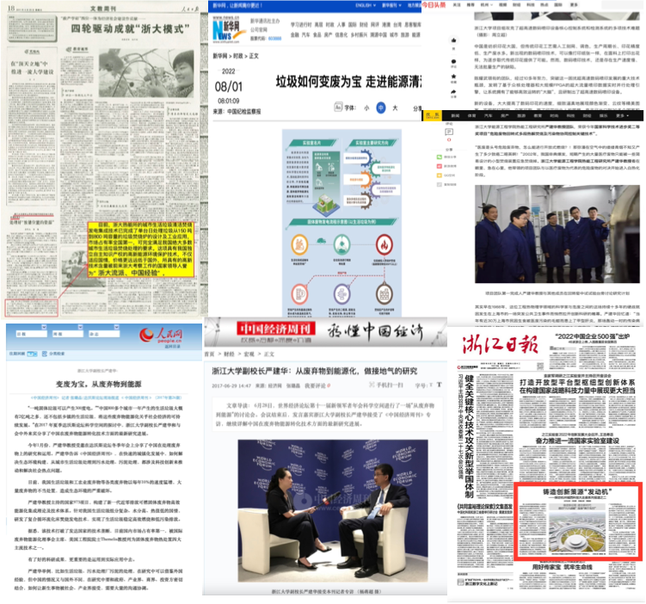
Figure 1. Prof Yan's achievements have been widely reported by a large number of well-known print media and websites such as People’s Daily, Xinhua Net, People.cn, China Economic Weekly, Sohu.com, Zhejiang Daily, etc.,
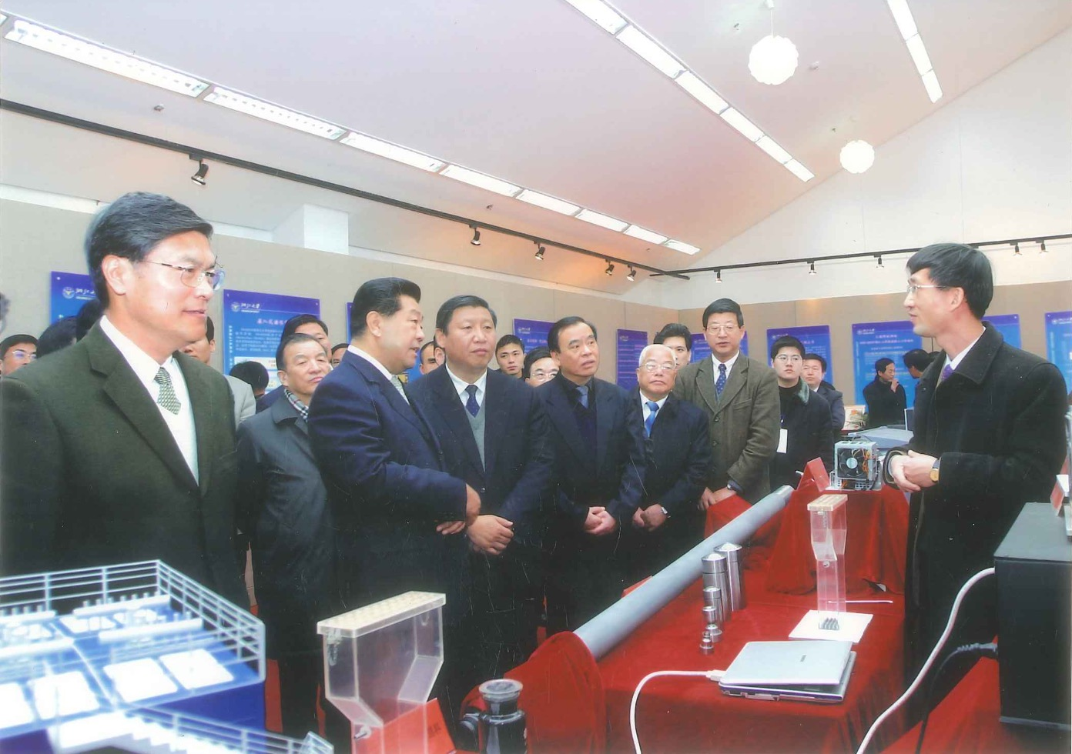
Figure 2. Prof. Yan presented a report to prominent Chinese leaders including Chairman Jia Qinglin, who was the Chairman of the National Committee of the Chinese People's Political Consultative Conference, and Xi Jinping, who served as the Secretary of the Zhejiang Provincial Party Committee at that time and currently holds the positions of General Secretary of the Communist Party of China and President of the People's Republic of China. The report highlighted the progress of Zhejiang University's research and application of waste-harmless energy conversion technology in industrial settings.
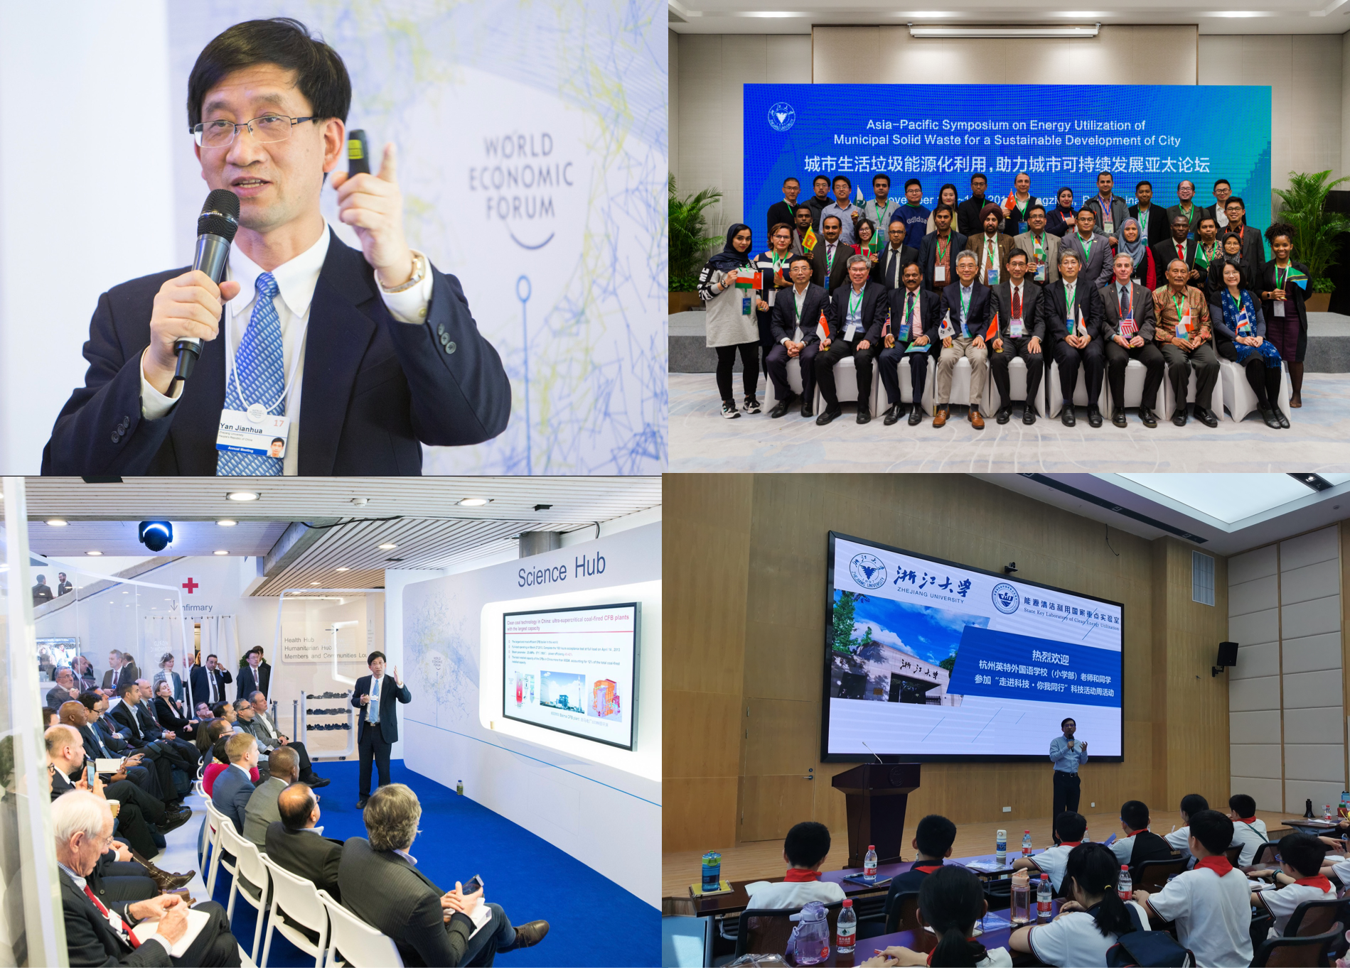
Figure 3. Prof. Yan introduced “Clean Coal Research at China” at the Davos Forum and discussed on energy utilization of municipal solid waste for the sustainable development of city energy utilization with experts from developing countries. Besides, he conducted science popularization campaigns for primary school students.

