Curriculum Vitae – CHUNGUANG XU

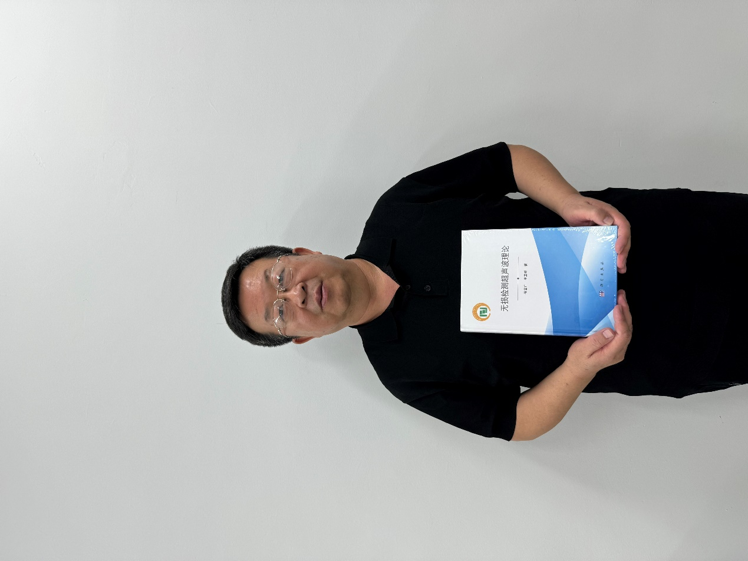

- Marital status:
married
- Office Address:
Rm#229, Bld#1
School of Mechanical Engineering, Beijing Institute of Technology
5 S. ZhongGuanCun Street, Haidian Dis.t, Beijing
100081 P.R. China

- Website:（Link to profile）

https://me.bit.edu.cn/szdw/jsml/zzgcx/jcykzyjs/bssds15/b25067.htm

- EDUCATION
1991.9-1995.1 | PH.D. Mechanical Engineering, Beijing Institute of technology, China
1985.7-1988.4 | M.D., Mechanical Engineering, Beijing Institute of Technology, Chin
1981.9-1985.7 | B.S., Mechanical Manufacturing and Automation, Bejing Institute of Technology, China

- DISTINCTIONS AND AWARDS
- National Defense Technology Invention Award, Second class prize 2022, 1st.
- Science and Technology Progress Award of the Xinjiang Uygur Autonomous Region, First class prize 2018, 8th.
- National defense technology invention award, Second class prize 2014, 1st.
- Military science and technology progress award, Third class prize 2014, 5th.
- Outstanding Supervisor of Ph.D. student, First class prize 2011, Exclusive.
- Outstanding Teacher of New Century, National Educaton Ministry 2005, Exclusive.
- Science and Technology Award of NORINCO GROUP, First class prize 2004, Exclusive.
- Science and Technology Award of State Administration of Science, Technology and Industry for National Defense, Third class prize 2004, 1st.
- National Defense Science and Technology Progress Award, Second class prize 2003, 2nd.
- Outstanding Young teacher, National Educaton Ministry 2003, Exclusive.

- EXPERIENCE

Permanent positions

2008-present | Professor，Director of Lab for NDT&Control, School of Mechanical Engineering, Beijing Institute of Technology
2012-2013 | Visiting Professor, Northwestern University, USA (Collaboration with Prof. Jan Drewes Achenbach, Distinguished McCormick School Professor)
2007-2008 | Adjunct Professor, Pennsylvanian State University, USA (Collaboration with Prof. Joseph L. Rose )
2003-2007 | Professor, Vice dean of school of the mechanical engineering, Beijing Institute of technology
2000-2003 | Professor, Vice dean of school of the mechanical engineering and automation, Beijing Institute of Technology
1995-2000 | Associate Professor, Vice dean of school of the mechanical engineering and automation, Beijing Institute of Technology
1988- 1991 | Lecturer, North China Electric Power University

Visiting positions
2009-present | Adjunct Professor of Pusan National University, Korea
2017-present | Guest Professor of China Academy of Engineering Physics (CAEP)
- OTHER PROFESSIONAL ACTIVITIES

Vice-chairman of 20th World Conference on Non-Destructive Testing (WCNDT 2020) | (2016-2020)
Committee Member of World Federation of Nondestructive Evaluation Center (WFNDEC) | (2015-)
Committee Member of Quantitative Nondestructive Evaluation Conference (QNDE) | (2013-)
Fellow of IEEE | (2009-)
Committee Member of International Society on Acoustic Emission | (2013-)
Committee Member of the American Society for Nondestructive Testing （ANST） | (2008-)
Committee Member of Canadian Institute for Non-destructive Evaluation （CINDE） | (2004-)
Fellow of Chinese Institute of Electronics (CIE) | (2007-)
Executive Chairman of IEEE Far East NDT Conference (IEEE FENDT) | (2013-)
Head, Co-Chairman:
2013- | Chair. Far East NDT Forum
Invited Speaker:
2023 | Invited Speaker, Title: Low stress manufacturing technology, June 13, 2023, 2023 Far East NDT Forum, Tianjin, China
- EDITOR:
- Reviewer of 《ISCM》(The International Society for Condition Monitoring) (2013-)

- GRANTS:
- Title: Metal Box Residual Stress Control Technology. Agency: National Key Projects; Amount: RMB 14,000,000; Period: 2023.01-2025.12; Role: Principal Investigator
- Title: Non-metal residual stress control technology. Agency: National Key Projects; Amount: RMB 6,500,000; Period: 2023.01-2025.12; Role: Principal Investigator
- Title: Research on key technologies of high-accuracy quantitative characterization and measurement of multi-dimensional stress field. Agency: National Key Projects; Amount: RMB 24,140,000; Period: 2022.01-2024.12; Role: Principal Investigator
- Title: Theory and Method of Residual Stress Ultrasonic Detection and Regulation. Agency: National Key Projects; Amount: RMB 23,000,000; Period: 2021.01-2025.12; Role: Principal Investigator
- Title: Development of prototype of residual stress control principle. Agency: National Key Projects; Amount: RMB 8,000,000; Period: 2021.01-2022.12; Role: Principal Investigator
- Title: Weak stiffness aluminum alloy component resiudal stress distribution ultrasonic nondestructive testing and high energy acoustic beam in situ control technology. Agency: The National Natural Science Foundation of China; Amount: RMB 2,550,000; Period: 2018.01-2021.12; Role: Principal Investigator
- Title: Characterization of Integrity of Electronic Package by Ultrasonic Nondestructive Testing. Agency: Key National Natural Science Founds of China; Amount: RMB 3,500,000; Period: 2014.01-2018.12; Role: Principal Investigator
- Title: The Theory and Method of Nondestructive Testing for 3D Residual Stress Profile by Ultrasonic Wave. Agency: National Natural Science Founds of China; Amount: RMB 1,500,000; Period: 2014.01-2016.12; Role: Principal Investigator
- Title: Ultrasonic Nondestructive Testing of Turbine Blade Robotically. Agency: Major National Science and Technology Projects/The Ministry of Science and Technology of the People’s Republic of China; Amount: RMB 5,000,000; Period: 2014.01-2016.12; Role: Principal Investigator
- Title: Regulation of Residual Stress by High Power Ultrasonics in Situ. Agency: National Natural Science Founds of China; Amount: RMB 600,000; Period: 2013.01-2015.12; Role: Principal Investigator
- Title: Ultrasonic Testing and Integrity Evaluation on Special Type of Composite Rotating Body. Agency: Major National Science and Technology Projects/The Ministry of Science and Technology of the People’s Republic of China; Amount: RMB 6,500,000; Period: 2011.01-2013.12; Role: Principal Investigator
- Title: Phased Array Ultrasonic Nondestructive Testing Technology. Agency: New century outstanding youth teacher plan of the national education ministry; Amount: RMB 500,000; Period: 2005.01-2007.12; Role: Principal Investigator

- HEAD OF APPLIED PROJECTS:
- Title: Aircraft Engine Blade Ultrasonic Nondestructive Testing Technology. Agency: National Key S&T Special Projects; Amount: RMB 12, 000,000; Period: 2013.01-2014.12; Role: Principal Investigator
- Title: Ultrasonic Nondestructive Testing and Evaluation for Irrotational Multilayer Composite Shell Body. Agency: International S&T Cooperation of the People’s Republic of China; Amount: RMB 4,800,000; Period: 2012.01-2014.12; Role: Principal Investigator
- Title: Geometry shape of surface corrosion defect detecting by ultrasonic guided waves transducer array. Agency: National Natural Science Foundation of China; Amount: RMB 300,000; Period: 2010.01-2012.12; Role: Principal Investigator
Supervision of Master and Ph.D. Theses
1999-present | PhD students:  Zhou Shiyuan; Meng Fanwu; Li Xipeng; Yan Hongjuan; Song Wentao; Cai Haichao; Lu Zongxing; Xiao Zhen; Yang Chao; Zhu Yanling; Li Peilu; Zhang Hanming; Guo Canzhi; He Lei; Lu Yuren; Yin Peng; Jiang Xiaowei
- PUBLICATIONS:
Books:
- Xu Chunguang(Editor). Robotic Non-destructive Testing Technology, CRC Press, 2022
- Xu Chunguang(Editor). Ultrasonic Microscopy Scanning Technology, Science Press, 2021
- Xu Chunguang(Editor). Fundamentals of Ultrasonic Testing, Beijing Institute of Technology Press, 2021
- Xu Chunguang(Editor). Nonlinear Ultrasonic Waves in Materials, Mechanical Beijing Institute of Technology Press, 2021
- Xu Chunguang(Editor). Theory of Ultrasonic in Nondestructive Testing, Science Press, 2020
- Xu Chunguang(Editor). Fundamentals of Ultrasonic Phased Arrays, National Defense Industry Press, 2017
- Xu Chunguang(Editor). Principles of Geometrical Measurement of Rotational Parts with Structured Light, National Defense Industry Press, 2017

Copyright certificates, patents:
1） | Nondestructive testing method for welding residual stress and probe using the method | US2020/0158585 A1
2） | Ultrasonic Detection and Tensile Calibration Test Method for Bonding Strength Grade | US-2022-0003791-A1
3） | Fixed Value Residual Stress Test Block and Manufacturing and Preservation Method Thereof | US10712316 B2
4） | Local Regulation Method and System of Residual Stress in Metal Components | 6373935(Japan patent)
5） | Sensor Device and Residual Stress Detection System Employing Same | US9863826 B2
6） | Non-Destructive Detecting Device for Component Residual Stress Gradient | US11226246 B2
7） | Residual Stress Test Block with a Certain Stress and Its Fabrication and Preservation Method | 5972480(Japan Patent)
8） | Ultrasonic Testing Device and Method | US10989696 B2
9） | A Sensor Device and A Residual Stress Detection System Using The Device | KR101804484
10） | Fixed Value Residual Stress Test Block and Manufacturing and Preservation Method Thereof | US9989496 B2

Articles and papers in peer-reviewed journals and edited volumes:
1. Yin Peng, Xu Chunguang, Pan Qinxue, Zhang Wenjun, Jiang Xiaowei. Study on ultrasonic regulation of the welding performance and defects of 7A52 aluminum alloy plate[J]. AIP Advances, 2022, 12(4): 045118.（SCI）
2. Yin Peng, Xu Chunguang, Pan Qinxue, Zhang Wenjun, and Jiang Xiaowei. Effect of Different Ultrasonic Power on the Properties of RHA Steel Welded Joints. Materials. 2022; 15(3):768. (SCI)
3. Yin Peng, Xu Chunguang, Pan Qinxue, Guo Canzhi, and Jiang Xiaowei. Effect of ultrasonic field on the microstructure and mechanical properties of sand-casting AlSi7Mg0.3 alloy. Reviews on Advanced Materials Science. 2021; 60(1):946-55. (SCI)
4. Li, Peilu, Chunguang Xu, Qinxue Pan, Yuren Lu, and Shuangyi Li. Denoising of LCR Wave Signal of Residual Stress for Rail Surface Based on Lifting Scheme Wavelet Packet Transform[J]. Coatings. 2021; 11(5): 496. (SCI)
5. Xu Chunguang, He Lei, Zhou Shiyuan, Xiao Dingguo, Ma Pengzhi. Evaluation of Damage Process of a Coating by Using Nonlinear Ultrasonic Method[J]. Coatings. 2021; 11(4):440. (SCI)
6. Lei He, Chunguang Xu, Pengzhi Ma, Qiutao Wang. Synthesis and Characterization of Mn2O3 nanorods as Anode Materials for Lithium Ion Batteries[J]. Int. J. Electrochem. Sci., 15 (2020) 5908-5915. (SCI)
7. Xu Chunguang, He Lei, Xiao Dingguo, Ma Pengzhi, Wang Qiutao. A novel high-frequency ultrasonic approach for evaluation of homogeneity and measurement of sprayed coating thickness[J]. Coatings. 2020;10(7):676 (SCI).
8. Guo Canzhi, Xu Chunguang, Hao Juan, Xiao Dingguo, Yang Wanxin. Ultrasonic non-destructive testing system of semi-enclosed workpiece with dual-robot testing system[J]. Sensors. 2019 ;19(15):3359. (SCI)
9. Zhu Yanling, Xu Chunguang, Xiao Dingguo. Denoising Ultrasonic Echo Signals with Generalized S Transform and Singular Value Decomposition[J]. Traitement du Signal. 2019; 36(2). (SCI)
10. Zhang Hanming, Xu Chunguang, Xiao Dingguo. Crack Assessment of Wheel Hubs via an Ultrasonic Transducer and Industrial Robot.[J]. Sensors, 2018, 18(12):4336. (SCI)
- Courses taught in 2000-2023:
2015-present | Professor, Teaching “Robots and Intelligent Manufacturing” for master students at Beijing Institute of Technology
2013-present | Professor, Teaching “Nondestructive Testing” for undergraduate students at Beijing Institute of Technology

